**Banco de Dados**

**812839 – Vinícius Miranda de Araújo**

**Hands On 06**

1. **Diagrama**

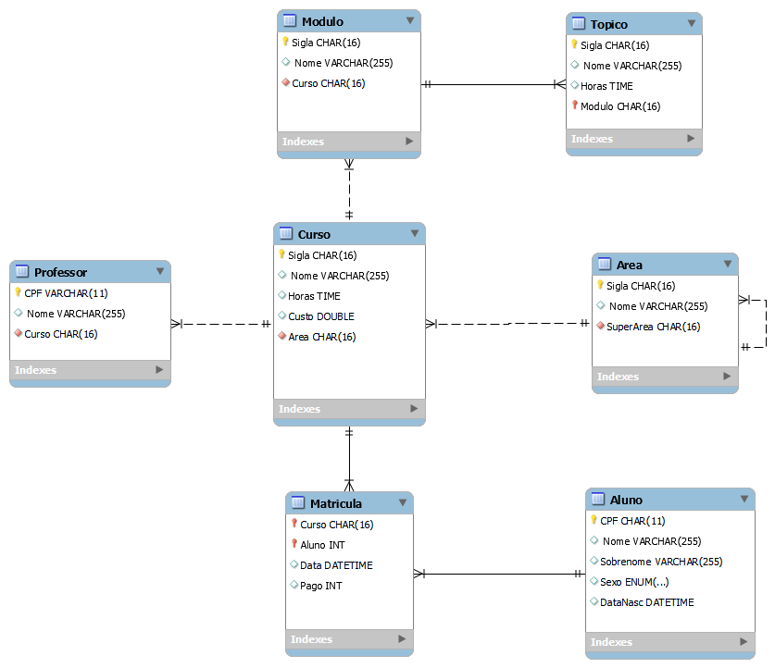

1. **Script**

CREATE SCHEMA IF NOT EXISTS `SAM` DEFAULT CHARACTER SET utf8;

USE `SAM`;

CREATE TABLE IF NOT EXISTS `SAM`.`Area` (

  `Sigla` CHAR(16) NOT NULL,

  ` Nome` VARCHAR(255) NULL,

  `SuperArea` CHAR(16) NOT NULL,

  PRIMARY KEY (`Sigla`),

  INDEX `fk_Area_Area1_idx` (`SuperArea` ASC) VISIBLE,

  CONSTRAINT `fk_Area_Area1`

    FOREIGN KEY (`SuperArea`)

    REFERENCES `SAM`.`Area` (`Sigla`)

    ON DELETE NO ACTION

    ON UPDATE NO ACTION)

ENGINE = InnoDB;

CREATE TABLE IF NOT EXISTS `SAM`.`Curso` (

  `Sigla` CHAR(16) NOT NULL,

  ` Nome` VARCHAR(255) NULL,

  `Horas` TIME NULL,

  `Custo` DOUBLE NULL,

  `Area` CHAR(16) NOT NULL,

  PRIMARY KEY (`Sigla`),

  INDEX `fk_Curso_Area_idx` (`Area` ASC) VISIBLE,

  CONSTRAINT `fk_Curso_Area`

    FOREIGN KEY (`Area`)

    REFERENCES `SAM`.`Area` (`Sigla`)

    ON DELETE NO ACTION

    ON UPDATE NO ACTION)

ENGINE = InnoDB;

CREATE TABLE IF NOT EXISTS `SAM`.`Modulo` (

  `Sigla` CHAR(16) NOT NULL,

  ` Nome` VARCHAR(255) NULL,

  `Curso` CHAR(16) NOT NULL,

  PRIMARY KEY (`Sigla`),

  INDEX `fk_Modulo_Curso1_idx` (`Curso` ASC) VISIBLE,

  CONSTRAINT `fk_Modulo_Curso1`

    FOREIGN KEY (`Curso`)

    REFERENCES `SAM`.`Curso` (`Sigla`)

    ON DELETE NO ACTION

    ON UPDATE NO ACTION)

ENGINE = InnoDB;

CREATE TABLE IF NOT EXISTS `SAM`.`Topico` (

  `Sigla` CHAR(16) NOT NULL,

  ` Nome` VARCHAR(255) NULL,

  `Horas` TIME NULL,

  `Modulo` CHAR(16) NOT NULL,

  PRIMARY KEY (`Sigla`, `Modulo`),

  INDEX `fk_Topico_Modulo1_idx` (`Modulo` ASC) VISIBLE,

  CONSTRAINT `fk_Topico_Modulo1`

    FOREIGN KEY (`Modulo`)

    REFERENCES `SAM`.`Modulo` (`Sigla`)

    ON DELETE NO ACTION

    ON UPDATE NO ACTION)

ENGINE = InnoDB;

CREATE TABLE IF NOT EXISTS `SAM`.`Aluno` (

  `CPF` CHAR(11) NOT NULL,

  ` Nome` VARCHAR(255) NULL,

  `Sobrenome` VARCHAR(255) NULL,

  `Sexo` ENUM('M', 'F', 'Outro') NULL,

  `DataNasc` DATETIME NULL,

  PRIMARY KEY (`CPF`))

ENGINE = InnoDB;

CREATE TABLE IF NOT EXISTS `SAM`.`Professor` (

  `CPF` VARCHAR(11) NOT NULL,

  ` Nome` VARCHAR(255) NULL,

  `Curso` CHAR(16) NOT NULL,

  PRIMARY KEY (`CPF`),

  INDEX `fk_Professor_Curso1_idx` (`Curso` ASC) VISIBLE,

  CONSTRAINT `fk_Professor_Curso1`

    FOREIGN KEY (`Curso`)

    REFERENCES `SAM`.`Curso` (`Sigla`)

    ON DELETE NO ACTION

    ON UPDATE NO ACTION)

ENGINE = InnoDB;

CREATE TABLE IF NOT EXISTS `SAM`.`Matricula` (

  `Curso` CHAR(16) NOT NULL,

  `Aluno` INT NOT NULL,

  `Data` DATETIME NULL,

  `Pago` INT NULL,

  PRIMARY KEY (`Curso`, `Aluno`),

  INDEX `fk_Curso_has_Aluno_Aluno1_idx` (`Aluno` ASC) VISIBLE,

  INDEX `fk_Curso_has_Aluno_Curso1_idx` (`Curso` ASC) VISIBLE,

  CONSTRAINT `fk_Curso_has_Aluno_Curso1`

    FOREIGN KEY (`Curso`)

    REFERENCES `SAM`.`Curso` (`Sigla`)

    ON DELETE NO ACTION

    ON UPDATE NO ACTION,

  CONSTRAINT `fk_Curso_has_Aluno_Aluno1`

    FOREIGN KEY (`Aluno`)

    REFERENCES `SAM`.`Aluno` (`CPF`)

    ON DELETE NO ACTION

    ON UPDATE NO ACTION)

ENGINE = InnoDB;